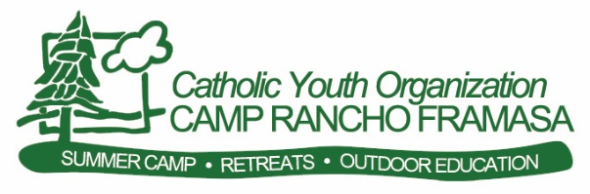

Program Staff

Application Handbook

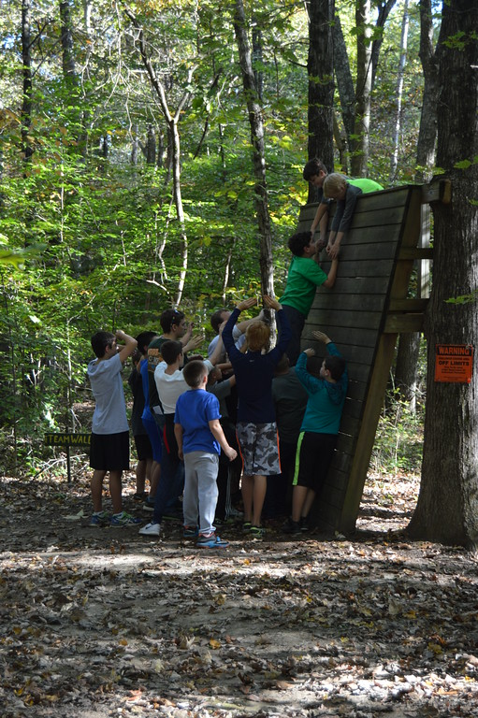

2230 N. Clay Lick Rd. Nashville, IN 47448

phone: 888-988-2839 x125

fax: 888-988-4842

angi@campranchoframasa.org

www.campranchoframasa.org

Table of Contents…pg. 2

ACA Accreditation………………………………………………………………2

About CYO Camp Rancho Framasa………………………………………………………3

Why Work at a Camp…………………………………………………………………3

The Camp Family……………………………………………………………………4

The Nearby Community…………………………………………………………4

Sample Schedules & Programming…………………………………………………………………………4

Program Staff Position Description………………………………………………………………5 & 6

Benefits & Challenges of Working at Camp…………………………………………………………7

Employment Information.……………………………………………………………………8 & 9

How Do I Apply?……………………………… ……………………………………9

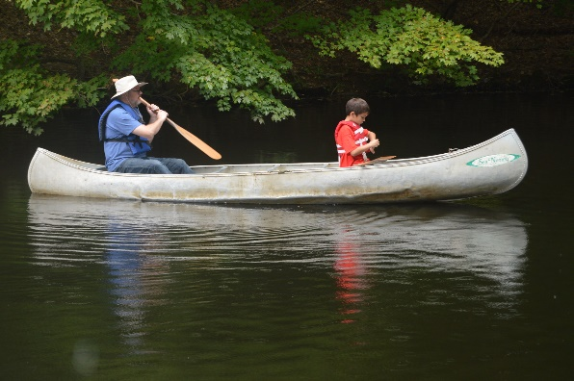

ACA Membership

Camp Rancho Framasa is proud to be accredited by the American Camp Association. Developed exclusively for the camp profession, this nationally recognized program focuses on program quality, health and safety issues, and requires us to review every facet of our operation. Camp Rancho Framasa has voluntarily submitted to this independent appraisal done by camp experts and has earned this mark of distinction.

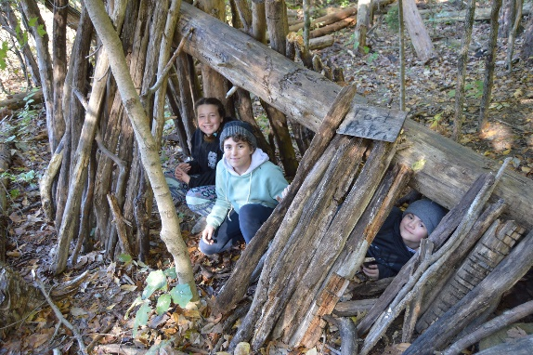
2
About Camp Rancho Framasa

Camp Rancho Framasa, established in 1946, facilitates a residential, inclusive Summer Camp, Outdoor Education, and Retreat program. It is located on 296 acres in Nashville, Indiana, just 65 miles south of Indianapolis. The site is very rural with steep hills, many trees, a small lake, trails, pastures, and fields. Camp facilities include: 4 rustic cabins & 4 heated cabins, health care center, an outdoor program center/dining hall, an amphitheater, an activity pavilion, summer, administrative, and program staff offices, guest house and 2 staff residences. Camp Rancho Framasa serves youth ages 7-18 during summer camp, and serves people of all ages during the rest of the year. Many of our participants come from Catholic schools and parishes throughout the Archdiocese of Indianapolis and surrounding areas.

The mission of Camp Rancho Framasa is to enhance the physical, emotional, and spiritual development of youth through experiences in the outdoors. School Year Programs offered include outdoor education, leadership programs, community programs, guest group hosting and retreats.

Camp Rancho Framasa is inclusive of all abilities, and trained staff members provide support to participants as needed. All programs are guided by 6 core values: Catholic, Inclusive, Stewards of the Earth, Staff Development, Humility and Participant Centered. These 6 values are integral in the way camp is organized and run on a daily basis. Camp Rancho Framasa is a program of the Catholic Youth Organization (CYO), Archdiocese of Indianapolis.

Why Work at Camp?
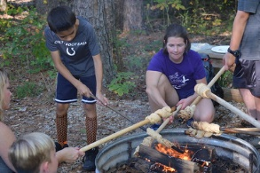
At camp, amazing things happen! Lives are changed as friendships and relationships are formed, new skills are learned, and an appreciation for the natural world is emphasized. This is true for students, teachers, adult chaperones, and camp staff. At camp, you will make a difference in individual’s lives and have an impact on the greater community as you model our core values and help others grow. Working with participants is an extremely rewarding experience. They look up to you. Everything you say and do sticks with them and can change the way they think about themselves and the world.

You will be part of an environment where people can “get dirty” and explore things hands-on. “Camp” experiences encourage people to try new things and challenge themselves beyond what they thought they could do. This is only possible by the support of caring and knowledgeable staff made up of people like you. Staff training focuses on the balance between safety and fun, education and recreation, individual accomplishments and teamwork. At the end of their stay, Program Staff leave camp with an increased ability to compromise and live in community, to protect and advocate for the natural world, communicate more effectively, connect with and serve others.

Is there more? Yes! Working at camp is a great opportunity to develop organizational skills, people skills, and leadership skills. Our core value of Staff Development means that you will be developing and working on your personal and professional goals. By working as part of a team and by accomplishing individual goals, you will experience growth in the above areas. You will also care for and manage groups of children, which will show that you are trustworthy, responsible, and compassionate. These skills can be transferred to any profession.
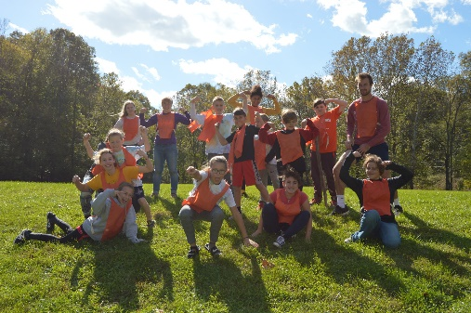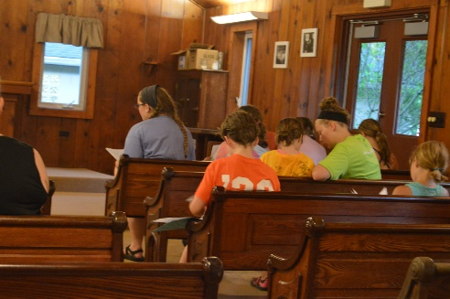
3

The Camp Family
At Camp Rancho Framasa, we are truly a camp family! Some of us live at camp year round, others live close by. By working at camp, all staff members become a part of the extended camp family. Those who are devoted to camp year round spend much of the year planning and organizing for the 12 very exciting months of the camp calendar.

YEAR ROUND STAFF

Kevin & Angi Sullivan, Camp Co-Directors
Steve Connaughton, Summer Program Director (onsite summer only)
Tom Gattuso, School Year Program Director
Lauren Verhiley, Registrar
Chris Parker, Facility Assistant
Lauren Owen, Assistant Camp Director
Chris “CB” Bryan, Facility Manager
Lyndsay Hill, Food Service Manager
Gary Roberts, Assistant Facility Manager

PROGRAM STAFF
Camp Rancho Framasa’s program staff is made up of 6 adults who have either graduated from college or have work experience in environmental education, outdoor recreation, education or related field. Their job is to facilitate the school year camp calendar, August through May, which involves outdoor education, retreats, guest groups and leadership programs, community programs, facility development and curriculum development.

SUMMER STAFF
Camp Rancho Framasa’s summer staff is made up of about 60 college age individuals. Many are in college studying a field that will enable them to work with children such as education, special education, human development and family studies, outdoor education, therapeutic recreation and more!

The Nearby Community

Camp Rancho Framasa is located near a variety of towns. Nashville, our neighbor 5 miles to the southwest, was originally an artist’s community. It has maintained its culture, and many local artisans sell their paintings, glasswork, ceramics, leatherwork, furniture, and folk art. There are also a number of local inns and restaurants, a beautiful library, a post office, a grocery store, a hardware store, a YMCA, and a few fast food places. Check out: www.nashvilleindiana.com.

Bloomington (home of Indiana University) and Columbus are both about a half-hour from camp and larger cities. If you want to travel further, Indianapolis (the capital of Indiana) is about an hour’s drive north, Louisville, KY is an hour and a half south and Cincinnati, OH is about 2 hours southeast. Brown County State Park, Yellowwood State Forest, Hoosier National Forest, Monroe Reservoir, and several other small lakes and rivers are all near to camp. There are a number of churches in the area, including Catholic churches. Nashville is home to St. Agnes parish (small, mostly adult congregation); Columbus is home to St. Bartholomew’s (very active families, teens and young adults); Bloomington is home to St. Charles (active, family-oriented) and St. Paul’s (very active, college and adult crowd). You do NOT have to be Catholic to work at CYO and there are multiple other churches close to camp.

Sample Program Schedule

Schedules vary according to the number of groups in a week and the season. We offer day only and overnight programming.

Arrival Day---

Departure Day---

8:00 am: Breakfast

8:45 am: Daybreak (reflection in Amphitheater)

9:00 am: Programming Begins

12:00 pm: Lunch at the Outdoor Program Center

1:00 pm: Closing Prayer and Departure

1:40 pm: Cleanup from group, store program supplies

2:30 pm: Staff meeting

9:00 am: Staff meeting, prepare for group arrival

10:00 am (or so): Group arrives- tour, orientations, group games

12:00 pm: Lunch at the Outdoor Program Center

1:00 pm: Programming Begins

6:00 pm: Dinner

7:15 pm: Evening Program

9:30 pm: Done for the day

Programming includes Retreats, Leadership, Recreation Community Building and Outdoor Education

Living History Outdoor Skills Astronomy

Challenge High and Low Courses Ecology Hiking

Campfires Indiana History Orienteering

Stewardship Spiritual Development Plants & Animals

Weather Astronomy

Recreation: canoeing, archery, sports, games, crafts

4

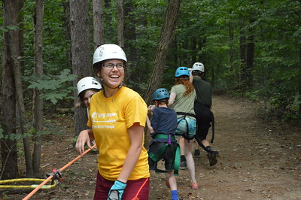
JOB DESCRIPTION

I. IDENTIFYING INFORMATION
Position Title: Program Staff
Status: August-November (1 semester); August through late May (full 9 month)
Or March-May (1 semester)
Reports To: Program Manager

II. PRIMARY FUNCTIONS
The Program Staff are primarily responsible for performing the duties of program facilitation for visiting groups in the following programs: outdoor education (history & science), leadership & community building, guest rental groups and CYO retreats. Other camp life/community responsibilities are also functions of the Program Staff.

III. POSITION CONTENT— RESPONSIBILITIES AND ACTIVITIES
A. Program Planning and Facilitation
- Teach or lead challenge, leadership, outdoor education, faith, and recreation activities.
- Interact with program participants and monitor their needs and safety.
- Follow daily and weekly schedules.
- Plan and implement lesson plans for specific program areas/classes.
- Clean, maintain, and keep inventory of specific program areas and equipment as assigned.
- Develop curriculum as needed.
- Prepare facilities and host guest groups.

Other Responsibilities and Regular Activities
- Housekeeping—assist in the cleaning and sanitation of cabins, camp program areas, and other camp property.
- Food Service—assist with assigned food service operations and snack duties.
- Facility Projects—during the winter season; assist with facility projects which may include painting, organizing, small building projects, planting, trail maintenance.
- Prepare for and actively participate in staff trainings and meetings.
- Demonstrate a willingness to provide service to others in the camp community and to camp’s guests and program participants.
- Show a respect for individual property, camp equipment, and facilities.
- Demonstrate responsibility and good judgment, decorum, politeness, appropriate dress, etc.
- Work to uphold the mission and philosophies of the Arch. of Indianapolis, the CYO and Camp Rancho Framasa.

IV. POSITION SPECIFICATIONS/REQUIREMENTS
A. Expectations and Abilities
- Plan and lead activities and events. This includes physical work outdoors in rugged terrain where mobility and stamina are important.
- Ensure participant’s safety, health, and respect during their experience.
- Participate in all staff events and support all members of the staff community.
- Maintain flexibility.
- Strive to learn and improve as a camp outdoor professional.
- Participate with enthusiasm and maintain a positive attitude and find an appropriate outlet for venting frustrations when necessary.
- Model 6 core values: Catholic, Inclusive, Stewards of the Earth, Staff Development, Humility, and Participant-Centered.

Education, Training, and/or Experience
- Must be at least twenty-one years of age and/or a college graduate.
- Must have relevant experience teaching/leading children.
- Must possess an ability to lead groups of children and adults in outdoor education and related activities.
- Experience leading retreats helpful.

5

VI. WORKING ENVIRONMENT
- Regular evenings and weekends are necessary (work weeks are 5-6 day weeks).
- Most work is performed outdoors and there will be exposure to the sun and elements.
- Camp Rancho Framasa is set in a wonderful hardwood forest. To maintain this, no- or low-impact outdoor ethics are necessary.
- Staff training will be provided, including curriculum design, planning, and teaching; behavior management techniques; small and large group facilitation; activity specialist training (canoeing, archery, low/high ropes, fire building, etc.) and specific training as needed for facility projects. During the course of the season, Program Staff are expected to adhere to standards and policies introduced during staff training.
- Program Staff must conduct themselves in a manner fitting their profession and role as an employee of Camp Rancho Framasa, both at camp and in the community.

VII. BENEFITS

9-month commitment (August 2, 2020-May 22, 2021)
SALARY of $600 per pay, received every two weeks for 21 ½ pays; Last work day May 26.

HEALTH INSURANCE for details visit: http://www.archindyhr.org/wp-content/uploads/2015/04/2015-Benefits-Summary2.pdf
HOLIDAYS - Labor Day; Weds, Thurs., Fri. of Thanksgiving; Christmas (3 weeks, begins the week before Christmas), MLK Day, Good Friday, Easter Monday
VACATION DAYS- 5 days
SICK DAYS- 5 days
PERSONAL DAYS- 2 days (1 per “semester”)
Personal, vacation & sick days DO NOT carry over or cash out.
Preferred months for taking vacation days are November, December, January, February, & early March.
Vacation day requests may be made for Sept., Oct., April, & May, but may be denied as a result of program needs.

Spring 2020 Semester commitment (Start Date negotiable-May 22)
SALARY of $600 per pay, received every two weeks for 7 ½ pays
HOLIDAYS – Good Friday, Easter Monday
VACATION DAYS - 3 days
SICK DAYS- 3 days
PERSONAL DAY - 1 day
Personal, vacation & sick days DO NOT carry over or cash out.
Preferred month for taking vacation days is April.
Vacation day requests may be made for busy months, but may be denied as a result of participant needs.

Fall 2020 Semester commitment (August 2-Nov 13)
SALARY of $600 per pay, received every two weeks for 7 ½ pays for a total of $3862.50
HOLIDAYS - Labor Day (fall)
VACATION DAYS - 3 days
SICK DAYS- 3 days
PERSONAL DAY - 1 day
Personal, vacation & sick days DO NOT carry over or cash out.
Preferred month for taking vacation days is November
Vacation day requests may be made for busy months. but may be denied as a result of participant needs.

The minimum on all time-off is 1/2 day increment. Staff members who choose to leave early will forfeit the days listed. They do not “cash out.”

- Housing (optional) is included through five (5) days past the end of the school year season. Housing may include roommates and/or housemates in gender specific residents. Program Staff who live off-site will have access to residential staff amenities.
- Board is included throughout the season. When groups are in camp, this will include prepared meals (vegetarian options, salad bar, fruit, and snacks available) at the camp’s dining hall (OPC). When groups are not in camp, staff has access to designated leftovers.
- Internet access, DVD, laundry facilities, in house kitchen are included.
- Accident insurance as covered under the Archdiocese of Indianapolis policy (workers compensation).
- Mileage reimbursement accumulated on personal vehicles if use is deemed necessary for work purposes.

6

More Benefits of Working at Camp

Working at camp as a Program Staff member gives you the opportunity to expand your teaching, classroom management, curriculum development, leadership, and facilitation skills. You will also gain valuable experience coordinating groups, planning programming, working within a close-knit team, and attending ongoing training sessions.

This description could become part of your resume:

Camp Rancho Framasa Program Staff

Worked within a team to provide environmental education, leadership development, and spiritual growth programs to schools and churches. Planned and executed unique curriculum materials and all-camp programs. Worked with teachers and other staff members to cater program to meet specified goals, objectives and state mandated proficiencies.

You will have made a difference in the lives of children. You will have shared your passion for the outdoors, for ministry, for leadership, for the protection of our natural world, for learning. You will have been part of a team that truly lives in community. The benefit of working at camp is one that stays with you for a lifetime.

The Challenges of Working at Camp

While working at camp is tons of fun and a great learning experience, you will also find challenges. We like to tell you about them so you can make an informed decision. Having strategies or the ability to work through these challenges can set you up for success.

Common Challenges:
Lack of privacy and “alone time.” When you live onsite, you have your own space within shared housing. You work, live, and play with the same small community of people. It’s a great way to build relationships, but respect and taking time away is very important.

The need to always be “on.” We work long hours some days, constantly busy with students/participants, teachers, and staff members. You are expected to participate with enthusiasm and support students in every moment, providing the best and safest possible experience. Each group, whether the first or last of the season, deserves the same quality of instruction and support from staff members. When you are in the local community, you will need to continue to reflect the mission and core values of Camp Rancho Framasa.

Difficult participants. We work with participants from a wide variety of parishes throughout the Archdiocese, as well as local public schools and organizations. Whether they come from the inner city, the suburbs, or a rural community, there are always students who will test your patience. They may call each other names or bully one another. They may have so much energy they can barely sit down. They may be loud when you wish they’d be quiet. All of these are typical for school trips to camp. You will learn strategies during staff training to help when issues arise.

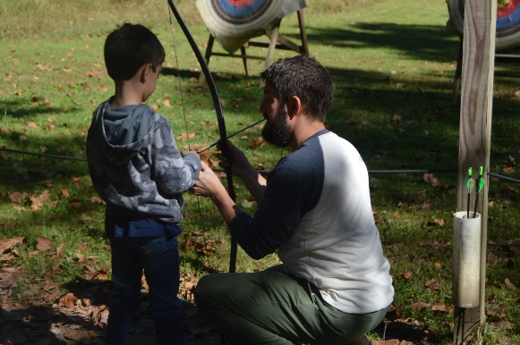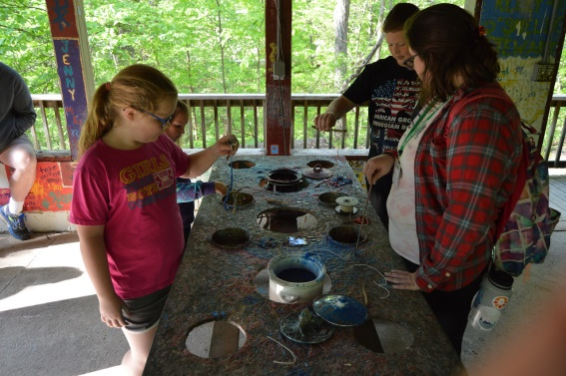

7

EMPLOYMENT INFORMATION

It is imperative that we provide every staff member and participant with a comfortable and safe living environment. To do this, we have specific rules that govern the way we treat people and property at camp and during camp sponsored activities. Take a look below at some of the information and guidelines for camp staff that would be important for you to know before accepting a job; other guidelines and policies are covered during training.

Staff training for Program Staff is mandatory and starts March 9 for Spring and August 2 (for Fall & full school year). Ongoing training occurs throughout the school year.

Our season is busiest from August to November and from March to May. We are focused on building our winter season. In addition to programming in the winter months Program Staff will be involved in overall camp development. This includes program and curriculum development and facility improvement and cleaning; this is also a time for more time off, shorter work days and longer weekends.

Smoking, drinking and drug policies are in place at camp. Smoking is permitted on a limited basis. There are designated areas and specified times for smoking. Smoking should never occur around a group or have an impact on your work with a group. Staff members are permitted to store and consume alcoholic beverages within the confines of staff housing when off-duty for the evening or weekend. Drinking should never occur around a group, directly before working with a group, or have an impact on your work. No one is to be on camp property while over the legal alcohol limit, and underage drinking is prohibited at all times. Illegal use of any controlled substance is strictly prohibited. Violation of any of these policies is grounds for dismissal.

Staff health is closely monitored. Illness or injury may preclude staff members from continuing work at camp. Workman’s compensation may not cover all cases; a staff member’s insurance provider would be financially responsible when so deemed. Decisions made regarding continued employment will be made by the camp administration and they will use several factors, including the recommendations of a licensed physician.

Working hours are generally about 40 hours per week, with varying schedules (one day you may work 8:00-5:00, another you might work 12:00-9:00). During our busy season the schedule is too full to allow for the typical 40-hour week. Program staff will typically receive 2 days off for every 5 days worked. These 2 days may not be Saturday & Sunday as Program Staff work many weekends. In addition, the days may not be consecutive.

Abuse or harassment of students or staff will not be tolerated. If an incident involving physical, verbal, or sexual abuse of students, teachers, chaperones, or camp staff, occurs it will result in dismissal.

Staff housing will be provided to any Program Staff who wish to live onsite. Houses are single-sex and contain common areas, a kitchen, laundry facilities, bathrooms and bedrooms. Married housing is not available. Pets may not be brought to camp. It may be necessary to move from one house to another during employment to accommodate staffing changes.

Faith programming is a strong component of our program and is based on the Catholic faith. However, you do not have to be Catholic to work at or attend camp. You should be comfortable working in a faith-filled/Catholic environment, willing to grow in your faith and willing to lead grace before meals. Retreats, prayer, daybreak services (15 minutes of reflection), and other faith activities are led by Program Staff. Training is provided.

Dress code policies reflect our desire to positively reflect our mission at Camp Rancho Framasa, and our role as professional educators and role models. Each Program Staff member will be given staff clothing and a name tag to be worn whenever groups are present in camp. We wear camp apparel so we are easily recognized by participants.

Dress Code Guidelines:

Shirts, shorts and pants should be well-fitted (not too tight/short/low-riding/midriff-baring, etc.)

Clothing should not display alcohol labels, sexual innuendos, curse words, or other slogans/graphics that could be offensive, pertain to a culturally divisive issue (such as recent wars, abortion, the death penalty, etc.) or conflict with the mission of camp (Catholic, Camper-Centered, Staff Development, Inclusive, Stewards of the Earth).

All staff members must wear undergarments. Shorts or tank tops are not an acceptable substitution.

Swimsuits worn while at camp should be conservative and allow you to move easily (no bikinis or sporty Speedos).

8
Pay checks are directly deposited every two weeks.

Gossip and negativity among the staff community are not tolerated and are grounds for dismissal.

Pets may not be brought to camp.

Living in community is an integral part of the Program Staff position. Shared housing, meals, work time and recreation activities are all opportunities to be “in community.” Families with children are among the camp staff community. All members participate in community meals, camp work and recreation with each other. It is important that each Program Staff member be comfortable with this type of environment.

How do I apply?

We hope you like what you have read about Camp Rancho Framasa. We invite you to complete the application.

We want you to make the best decision for your career & personal growth!

The following are the steps to take to ensure your application/hiring process goes smoothly.

- Complete the application form online. Please be honest. Failure to fully disclose information can be cause for rejection of your application or withdraw of any offer of employment at any time.
- REFERENCES: New staff applicants are required to provide 2 references. List names and contact information on your application. Please list teachers, past or present employers or a member of the clergy. A reference link will be sent to those listed. References completed by co-workers, family members or friends will not be considered and will delay the application process.
- Someone may contact you to either arrange for an interview or to let you know the status of your application.
- If you are offered a position, please take the time to think over what was discussed at your interview. You may even want to review the application handbook. Camp is a big commitment. Please be sure this is the right job for you before you accept a position.

Please direct staff inquiries to:
Camp Rancho Framasa
Angi Sullivan
angi@campranchoframasa.org

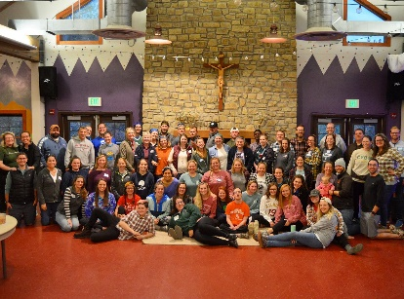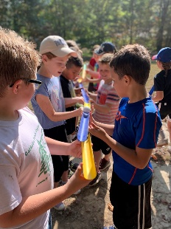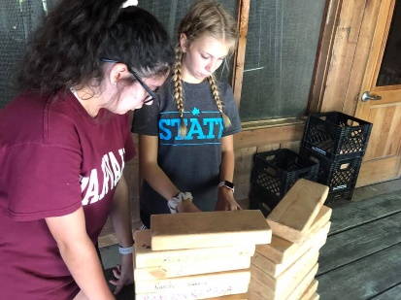

9

